**Project 5: The Assembler**

**Background**

Low-level machine programs are rarely written by humans. Typically, they are generated by compilers. Yet humans can inspect the translated code and learn important lessons about how to write their high-level programs better, in a way that avoids low-level pitfalls and exploits the underlying hardware better. One of the key players in this translation process is the assembler -- a program designed to translate code written in a symbolic machine language into code written in binary machine language.

This project marks an exciting landmark in our Nand to Tetris odyssey: it deals with building the first rung up the software hierarchy, which will eventually end up in the construction of a compiler for a Java-like high-level language. But, first things first.

**Objective**

Write an Assembler program that translates programs written in the symbolic Hack assembly language into binary code that can execute on the Hack hardware platform built in the previous projects.

**Contract**

There are three ways to describe the desired behavior of your assembler: (i) When loaded into your assembler, a Prog.asm file containing a valid Hack assembly language program should be translated into the correct Hack binary code and stored in a Prog.hack file. (ii) The output produced by your assembler must be identical to the output produced by the Assembler supplied with the Nand2Tetris Software Suite. (iii) Your assembler must implement the translation specification given in Chapter 6, Section 2.

**Resources**

The relevant reading for this project is Chapter 6. Your assembler implementation can be written in any programming language (Java and Python being popular choices). Two useful tools are the supplied Assembler and the supplied CPU Emulator, both available in your tools directory. These tools allow experimenting with a working assembler before setting out to build one yourself. In addition, the supplied assembler provides a visual line-level translation GUI, and allows code comparisons with the outputs that your assembler will generate.

**Proposed Implementation**

Chapter 6 includes a proposed, language-independent Assembler API, which can serve as your implementation's blueprint. We suggest building the assembler in two stages. First, write a basic assembler designed to translate assembly programs that contain no symbols. Next, extend your basic assembler with symbol handling capabilities, yielding the final assembler. The test programs that we supply below are designed to support this staged implementation strategy.

**Test Programs**

Each test program except the first one comes in two versions: Prog.asm is an assembly program; ProgL.asm is the very same program, Less the symbols (each symbol is replaced with an explicit memory address).

|  |  |
| --- | --- |
| Program | Description |
| Add.asm | Adds up the constants 2 and 3 and puts the result in R0. |
| Max.asm | Computes max(R0,R1) and puts the result in R2. |
| Rect.asm | Draws a rectangle at the top-left corner of the screen. The rectangle is 16 pixels wide and R0 pixels high. |
| Pong.asm | A single-player Pong game. A ball bounces off the screen's "walls". The player attempts to hit the ball with a paddle by pressing the left and right arrow keyboard keys. For each successful hit, the player gains one point and the paddle shrinks a little, to make the game slightly more challenging. If the player misses the ball, the game is over. To quit the game, press the ESC key. |

The Pong program supplied above was written in the Java-like high-level Jack language and translated into the Hack assembly language by the Jack compiler (Jack and the Jack compiler are described in Chapter 9 and in Chapters 10-11, respectively). Although the original Jack program is only about 300 lines of Jack code, the executable Pong code is naturally much longer. Running this interactive program in the supplied CPU Emulator is a slow affair, so don't expect a high-powered Pong game. This slowness is actually a virtue, since it enables your eye to track the graphical behavior of the program. And don't worry! as we continue to build the software platform in the next few projects, Pong and and other games will run much faster.

**Tools**

The supplied Hack Assembler shown below is guaranteed to generate correct binary code. This guaranteed performance can be used to test if another assembler, say the one written by you, also generates correct code. The following screen shot illustrates the comparison process:

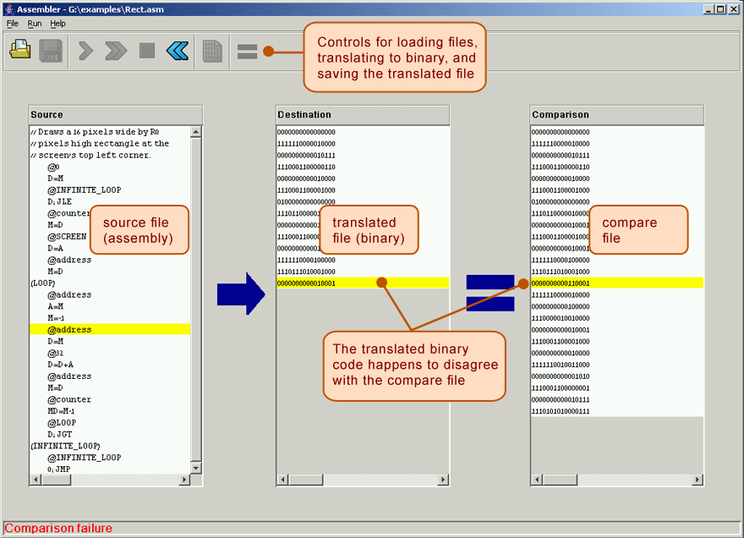

**The comparison logic:** Let Prog.asm be some program written in the symbolic Hack assembly language. Suppose we translate this program using the supplied assembler, producing a binary file called Prog.hack. Next, we use another assembler (e.g. the one that you wrote) to translate the same program into another file, say MyProg.hack. Now, if the latter assembler is working correctly, it follows that Prog.hack == MyProg.hack. Thus, one way to test a newly written assembler is as follows: (i) load into the supplied visual assembler Prog.asm as a source program and MyProg.hack as a compare file, (ii) translate the source program, and (iii) compare the resulting binary code with the compare file (see the figure above). If the comparison fails, the assembler that generated MyProg.hack must be buggy; otherwise, it may be OK.